**1.Create a Flask Application that accept Student Name And Roll no From the URL and Print The Message Like.. Welcome : Student Name... Roll no is : Roll no.**

**Ans:**

from flask import Flask

app=Flask(__name__)

@app.route('/<name>/<roll>')

def info(name,roll):

    return '<h2>Welcome : '+ name + '<br> Your Rollno is : '+ str(roll) + '</h2>'

if __name__=='__main__':

    app.run(debug=True)

**Output:**

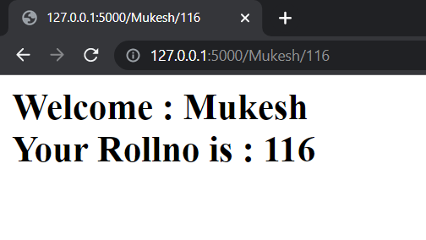

**2. Create a Flask Application That Have Pages Like Faculty, Student and Department According The Page Relevant Message Should Be Print.**

**Ans:**

from flask import Flask,render_template

app=Flask(__name__)

@app.route('/')

def index():

    return render_template("index.htm")

@app.route("/faculty")

def faculty():

    return render_template("faculty.htm")

@app.route("/stud")

def stud():

    return render_template("student.htm")

@app.route("/dept")

def dept():

    return render_template("dept.htm")

if __name__=='__main__':

    app.run(debug=True)

* **index.htm**

{% block content %}

<h1>Select Any Option To Redirect Particular Page....</h1>

<a href="/faculty"><button>Faculty</button>

<a href="/stud"><button>Student</button>

<a href="/dept"><button>Department</button>

{% endblock %}

* **faculty.htm**

<html>

<head>

    <title>Faculty Page</title>

</head>

<body>

    <h1>Welcome To Faculty Page</h1>

</body>

</html>

* **student.htm**

<html>

<head>

    <title>Student Page</title>

</head>

<body>

    <h1>Welcome To Student Page</h1>

</body>

</html>

* **dept.htm**

<html>

<head>

    <title>Department Page</title>

</head>

<body>

    <h1>Welcome To Department Page</h1>

    <ul>

        <b>

        <li>BCA</li>

        <li>BBA</li>

        <li>MCA</li>

        <li>MBA</li>

        </b>

    </ul>

</body>

</html>

**Output:**

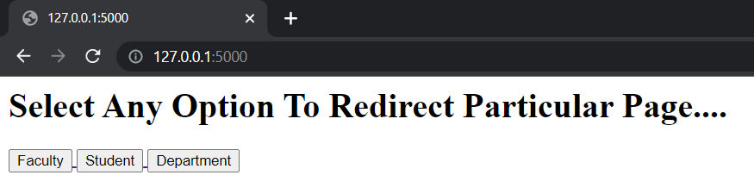

**3. Create a Flask Application That Embed Python Code and Check Given Number Is Palindrome Series Or Not**

**Ans:**

from flask import Flask,request

app=Flask(__name__)

def check_palindrome(num):

     temp=num

     rev=0

     while(num>0):

          dig=num%10

          rev=rev*10+dig

          num=num//10

     if(temp==rev):

          return True

     else:

          return False

@app.route("/",methods=["GET"])

def home():

     num=request.args.get("num",default=212,type=int)

     res=check_palindrome(num)

     if res:

          return f"<h1>{num} Is a Palindrome Number</h1>"

     else:

          return f"<h1>{num} Is Not Palindrome Number</h1>"

if __name__=="__main__":

     app.run(debug=True)

**Output:**

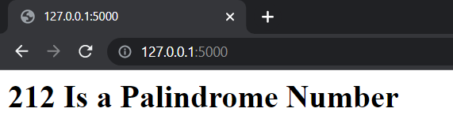

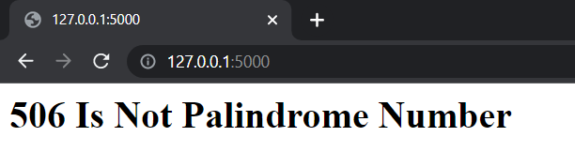

**4.Create A Student Bio-Data Like Frist Name, Last Name , Mobile No, Address etc. Using Request Object Display it In Tabular Form**

**Ans:**

from flask import Flask, render_template, request

app = Flask(__name__)

@app.route('/')

def bio():

    return render_template('bio.htm')

@app.route('/result',methods=['POST','GET'])

def result():

    if request.method == 'POST':

        result= request.form

        return render_template("result.htm",result=result)

if __name__=='__main__':

    app.run(debug = True)

* **bio.htm**

<html>

    <body>

      <form action="http://127.0.0.1:5000/result" method="POST">

        <p>Frist Name:<input type="text" name="Frist Name"></p>

        <p>Last Name:<input type="text" name="Last Name"></p>

        <p>Mobile No:<input type="text" name="Mobile No"></p>

        <p>Department:<input type="text" name="Department"></p>

        <p>Address:<input type="text" name="Address"></p>

        <p><input type="submit" value="submit"></p>

      </form>

    </body>

</html>

* **result.htm**

<html>

    <body>

        <table border="3">

            {% for key,value in result.items() %}

            <tr>

                <th>{{key}}</th>

                <td>{{value}}</td>

            </tr>

            {% endfor %}

        </table>

    </body>

</html>

**Output:**

